Retention Setup for Marine Product, The same is Applicable for All products:

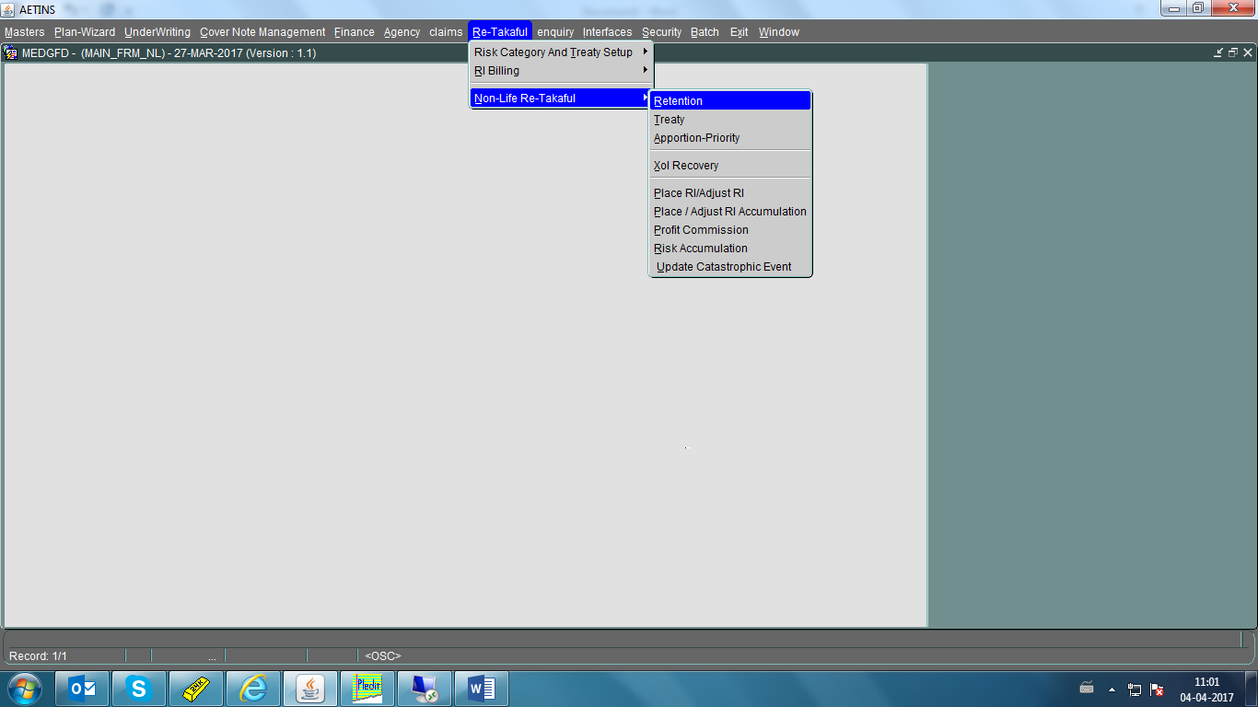

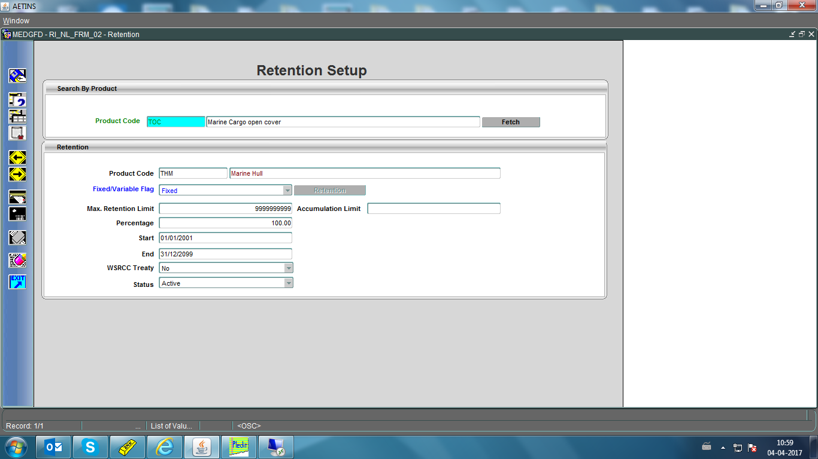

Treaty and Retention Order Setup for Product can be found from below screen:

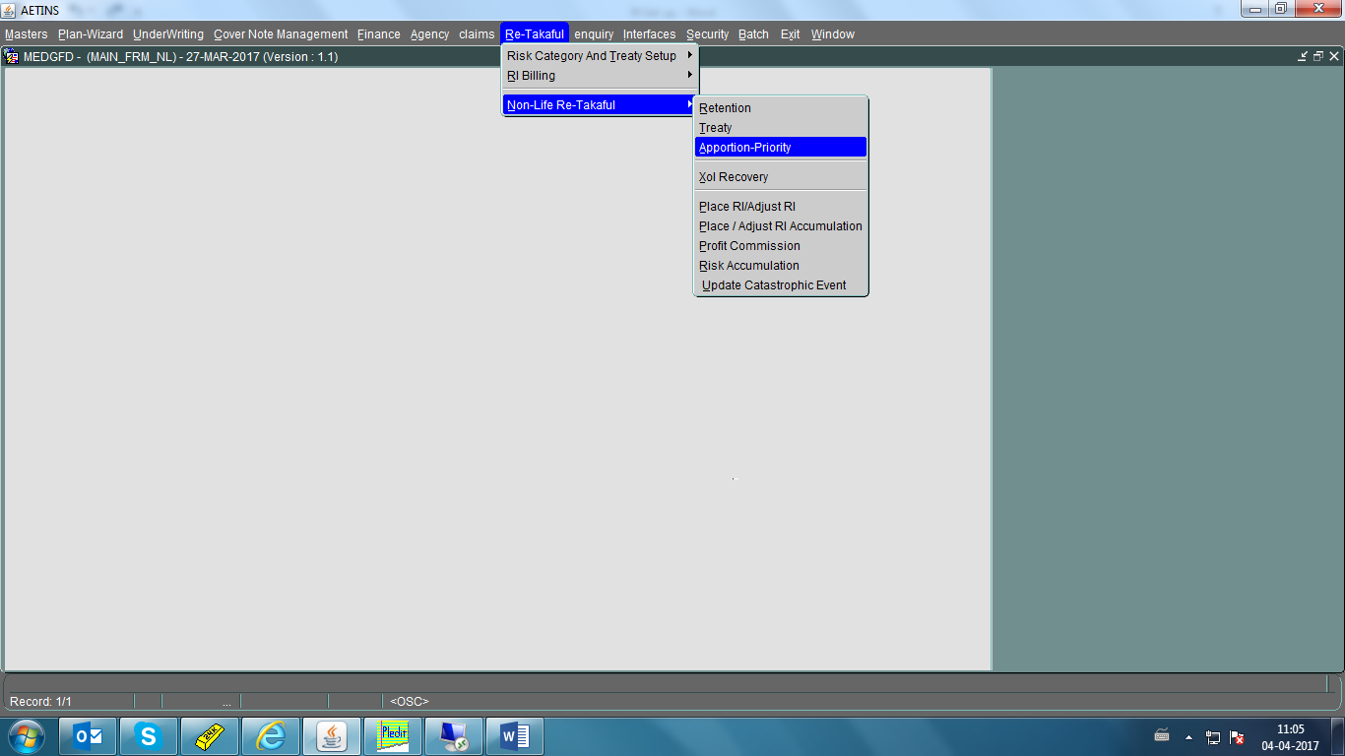

Priority of Treaty for particular product is Based on priority field and Valid from and Valid to of Treaty is based on from and To Date as shown in below screen shot:

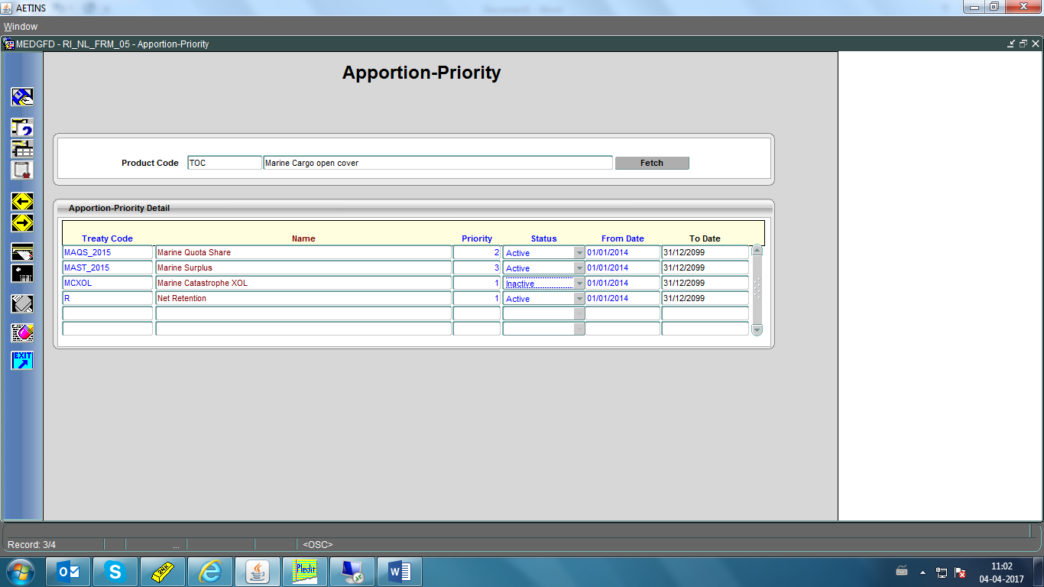

Treaty Related Information Can be found from below screen:

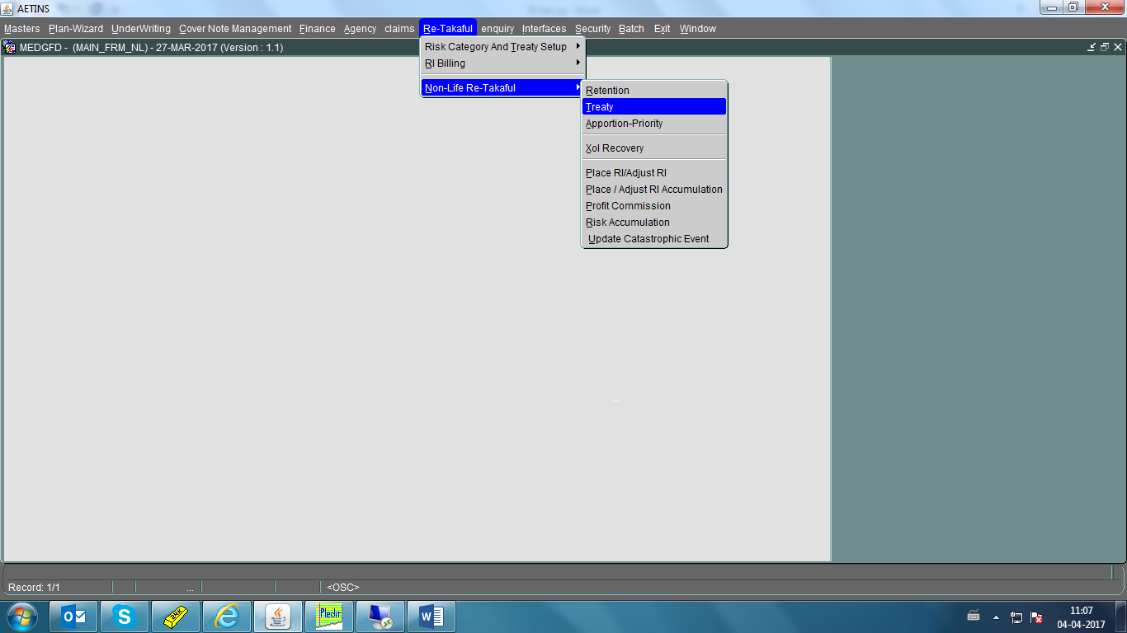

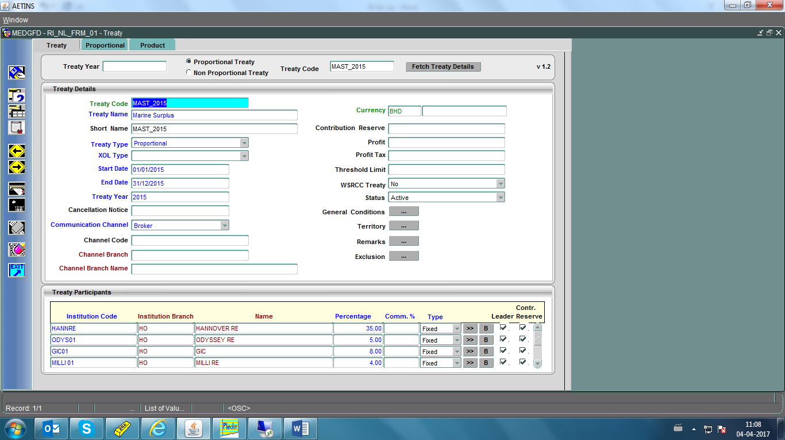

Maximum Ceding limit of Treaty can be found from below screen:

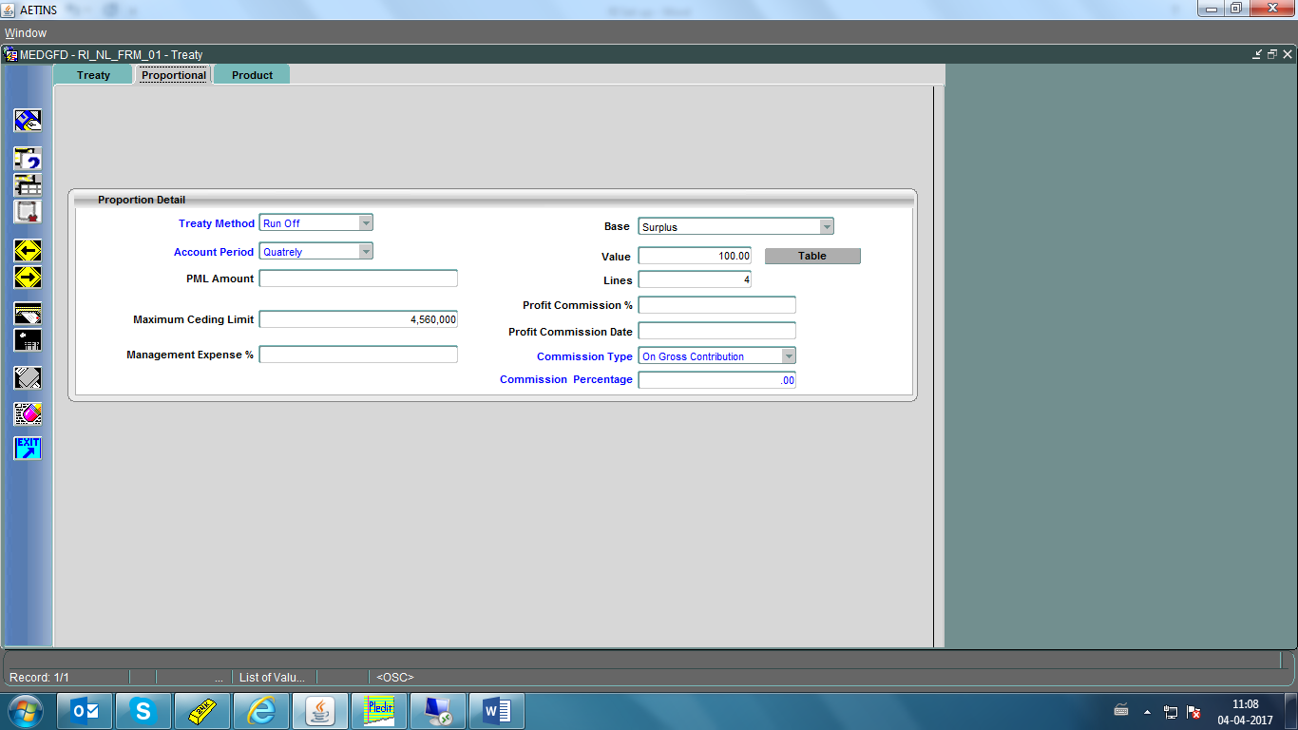

This Treaty is attached to which products can be shown from product Tab of this screen:

